Hackathon 2.0

(06-06-2023)

1. Triangles data

The Triangles table is described as follows:

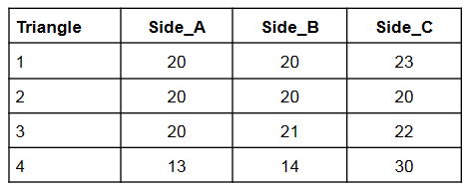

Questions:

1. Write a query to create the TRIANGLES table. (Note:-In answer, submit all the table creation queries.)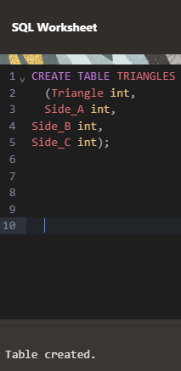

Ans.

Step 1.

CREATE TABLE TRIANGLES

(Triangle int,

Side_A int,

Side_B int,

Side_C int);

Step2.

INSERT INTO TRIANGLES VALUES (1, 20, 20, 23);

INSERT INTO TRIANGLES VALUES (2, 20, 20, 20);

INSERT INTO TRIANGLES VALUES (3, 20, 21, 22);

INSERT INTO TRIANGLES VALUES (4, 14, 14, 30);

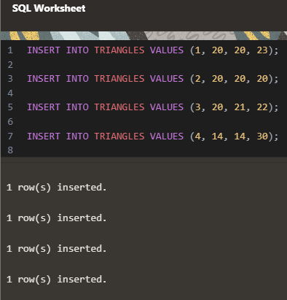

1. Write queries to get output as per required:
2. Write a query to obtain the sum of side_A of all triangles.

Ans.

SELECT SUM(SIDE_A) AS SUM_SIDE_A

FROM TRIANGLES;

1. Write a query to obtain an equilateral triangle from the table.

Ans.

SELECT *

FROM TRIANGLES

WHERE SIDE_A=SIDE_B AND SIDE_B=SIDE_C;

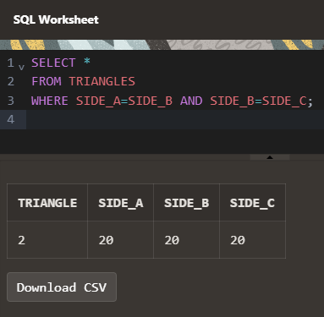

1. Write a query to obtain an isosceles triangle from the table.

Ans.

SELECT *

FROM TRIANGLES

WHERE (SIDE_A=SIDE_B AND SIDE_B<>SIDE_C)

OR (SIDE_B=SIDE_C AND SIDE_A<>SIDE_C)

OR (SIDE_A=SIDE_C AND SIDE_B<>SIDE_A);

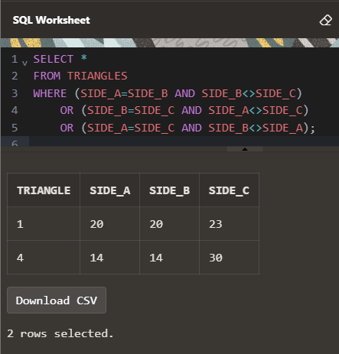

1. Find the no. of triangles in the table.

Ans.

SELECT COUNT(*)

AS Number_of_Triangles

FROM TRIANGLES;

1. Find the length of Side_ B of Triangle 3.

Ans.

SELECT TRIANGLE, SIDE_B

FROM TRIANGLES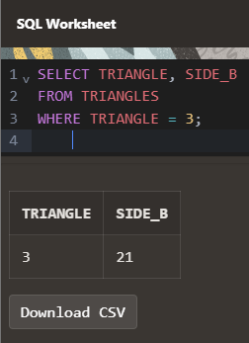

WHERE TRIANGLE = 3;

**2.Employees Data**

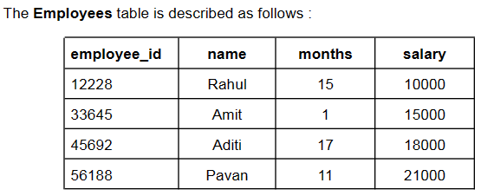

1. Write a Query to create the Employee table.

Ans.

Step 1.

CREATE TABLE Employees

(employee_id int,

name varchar(5),

months int,

salary int);

Step2.

INSERT INTO Employees values (12228,'Rahul', 15, 10000);

INSERT INTO Employees values (33645,'Amit', 1, 15000);

INSERT INTO Employees values (45692,'Aditi', 17, 18000);

INSERT INTO Employees values (56188,'Pavan', 11, 21000);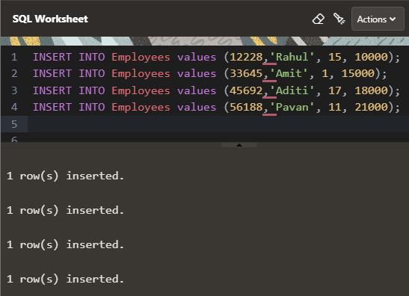

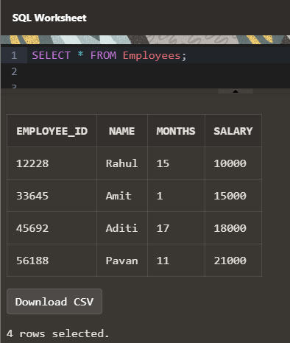

1. Write queries to get output as per required:
2. Count the total no. of employees.

Ans.

SELECT COUNT(*) as Total_Employees FROM Employees;

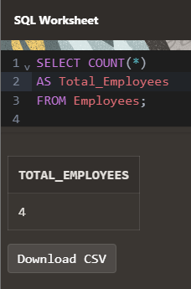

1. Find the salary of Rahul.

Ans.

SELECT NAME, SALARY

FROM Employees;

WHERE NAME='Rahul';

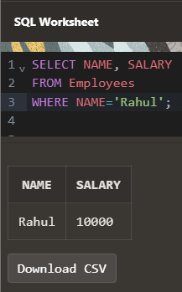

1. Set Amit’s months to 12.

Ans.

UPDATE EMPLOYEES

SET MONTHS = 12

WHERE NAME = 'Amit';

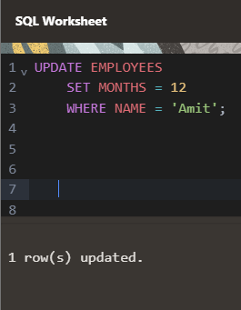

1. Find the sum of salaries of all employees.

Ans.

SELECT SUM(SALARY)

FROM Employees;

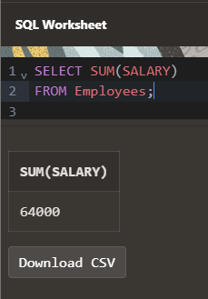

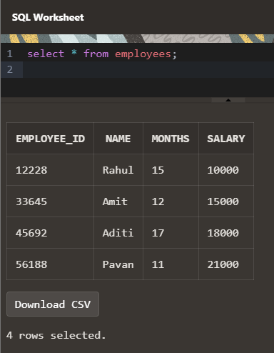

v) Find no. of employees whose name starts with ‘A’.

Ans.

SELECT COUNT(NAME)

FROM Employees

WHERE NAME LIKE 'A%';

